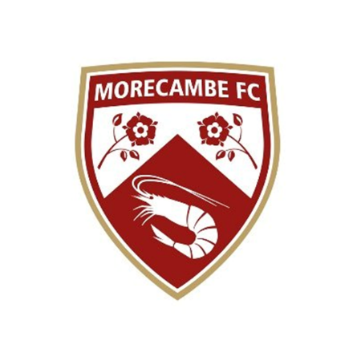

  - JOB DESCRIPTION

The Retail & Marketing Executive has responsibility for managing, controlling and optimising the online retail performance of Morecambe Football Club (MFC). Reporting to the Head of Commercial with responsibility for the online retail function, they will be tasked with creating and developing the club’s retail offering online, forecasting and helping to improve retail performance. The Executive will also develop our marketing function with innovative ideas and implementation. In doing so, they will play a key role in achieving MFC’s strategic vision of being competitive and sustainable in League One.

  - Morecambe FC - Retail & Marketing Executive
- Department | - Commercial
- Reports to | - Head of Commercial
- Contract | - Full Time
- Full terms of agreement | - To be discussed upon successful application
- Hours of work | - 38 hours, 5 days over 7 with evening, weekend and bank-holidays required
- Remuneration | - Competitive to be discussed based on experience
- Holiday entitlement | - To be discussed
- Key internal relationships | - Head of Stadium Operations, General Manager, Head of Commercial, Ticket Office Manager, Board of Directors, Retail & Ticketing Assistant
- Purpose of the role | - At Morecambe FC, our retail business has been expanding rapidly. The opportunity has arisen for a fulltime member of staff to join our team, with the responsibility for managing and processing online retail activity, and further developing this growing area of the business. We have invested heavily in a new online retail platform and the role will be pivotal in its success. The role will involve both the routine daily managing of orders received, together with associated customer service, and the longer-term development of the online retail business, including sourcing of new products and development of new sales channels. To assist and improve the functionality of the marketing operation of the club, offering insight and ideas in order to develop.
- Key Tasks &  - Responsibilities |  | - ● To be responsible for the growth of Morecambe FC retail operation, both online and instore  - ● To source new product ranges and grow the offering of the retail element of the Commercial department  - ● To produce a weekly Newsletter to be sent out to the database from customers that have opted in.  - ● Management of the retail promotional plans, inputting key information on to the systems and managing any changes and updates.  - ● Arrange marketing material and artwork for all promotions throughout the year  - ● Ensure the retail invoices are signed off correctly and entered on to the system  - ● Taking ownership of ad hoc and regular retail reports as requested by the department head.  - ● Communicating extensively throughout the teams to ensure all of them are fully up to date.  - ●Manage and develop an efficient and profitable retail arm of Morecambe FC.  - • Maximise sales income and profitability.  - • Monitor and manage all retail stock and merchandise.  - • Deliver exceptional levels of customer service.  - • Work as part of the Commercial Team.  - Stock Management  - • Complete yearly and rolling stock takes to ensure physical stock levels are consistent with system counts.  - • Manage all ordering of stock.  - • Ensure the stock room has the correct stock profile to support shop floor sales.  - • Carry out visual merchandising and run promotional campaigns.  - Reporting  - • Report on sales targets / performance on a weekly / monthly basis.  - • Attend monthly team meetings.  - • Attend other meetings as and when required by the Head of Commercial, General Manager.  - Customer Service  - • Provide outstanding customer service to each and every customer.  - • Leave a lasting, positive impression and encourage a return purchase.  - • Ensure customer data is collected and recorded within the CRM and to work to proactively develop the CRM.  - Online Store  - • Ensure all stock is available within the Online Store.  - • Ensure product descriptions, prices and stock is listed accurately.  - • Ensure the online shop is optimised and user friendly to drive sales  - • Run promotions and special offers.  - Other  - • Contribute creative ideas to improve the profitability of the Club Shop.  - • Develop good working relationships with various suppliers.  - • Work flexibly and outside normal working hours as and when required to meet the needs of Morecambe FC

  - Morecambe FC
  - PERSONAL SPECIFICATION
 |  | - Essential |  | - Desirable
  - Knowledge & Experience
 | - An interest in retail and personal development
 | - Experience of working in a retail environment
 | - Experience of working with the general public, face to face and on the telephone
 | - IT literate skills, with the ability to use the full Microsoft Office package
 | - Track record delivering quality customer service and client satisfaction.
 | - Ability to work flexibly across a 6-day working week including evening, weekends and bank holidays
  - Personal Qualities & Skills
 | - Interpersonal skills – must be a consistent team performer and able to forge excellent working relationships
 | - Have a polite and courteous manner and a personable approach
 | - Energetic and forward thinking
 | - Can offer solutions to problems, using initiative and common sense
 | - Willing to work in high pressure situations
 | - Confident, positive and happy speaking/interacting with people
 | - Be organised and have good time management skills
 | - Reliable and dependable at all times
 | - Honest, reliable and trustworthy
  - Safeguarding
 | - To have due regard for safeguarding and child protection policies, including the welfare of children and young people
 | - All Employees are subject to DBS checks, with our safeguarding officer
  - Other
  - A willingness to learn and develop as an individual through CPD
  - Applicants must be over the age of 18

  - The Employee must at all times carry out his/her responsibilities with due regard to Morecambe FC policies and procedures.
  - The Employee must act to protect all young people and vulnerable adults that are in their care, following the Club’s Safeguarding and Child Protection Policy at all times. The Employee must report any misconduct or suspected misconduct to the Safeguarding Manager.
  - The Employee must ensure a positive commitment towards equality and diversity by treating others fairly and not committing any form of direct or indirect discrimination, victimisation or harassment of any description and to promote positive working relations amongst employees, Employee and customers.
  - The above Role Description is not intended to be exhaustive, the duties and responsibilities may therefore vary over time according to the changing needs of the Club.

