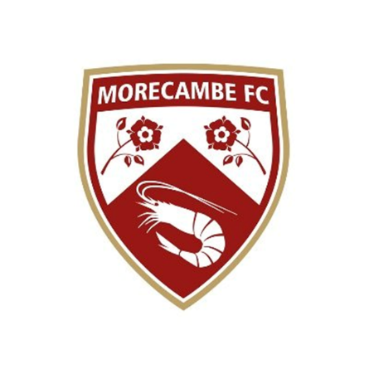

  - Morecambe Football Club are on the lookout for a new Business Development Executive. The successful candidate will deliver a high-quality sales service to the Mazuma Stadium and Morecambe Football Club through effective lead generation of new matchday and non-matchday events, commercial inventory, and conferencing facilities at the stadium. The role will involve matchday work, which is usually a Saturday and Tuesday evening. The role will be a full-time permanent role. All those who join the team will benefit from access to exclusive club events and ongoing training and development opportunities. If this is of interest to you, please refer to the below job description and complete our application form, returning this along with your CV to recruitment@morecambefc.com

  - JOB DESCRIPTION

  - Morecambe FC - Business Development Executive
- Department | - Commercial
- Reports to | - Head of Commercial
- Contract | - Full time, permanent
- Full terms of agreement | - To be discussed upon successful application
- Hours of work | - 40 hours, 5 days over 7 with evening, weekend and bank-holidays required
- Remuneration | - Competitive, with target driven incentive
- Holiday entitlement | - 28 days inclusive of Bank Holidays
- Key internal relationships | - Head of Commercial, Events Manager, Head of Hospitality & Events, Head of Media & Communications, Head of Finance
- Purpose of the role | To generate and drive a variety of Club business, ultimately increasing revenue across both matchday and non matchday streams, Club events and use of our conferencing facilities. Reporting to the Head of Commercial, you will develop effective relationships with clients and stakeholders, both internally and externally, and consistently portray a high-quality professional image and experience for all.
- Key Tasks &  - Responsibilities | - Responsible for the lead generation and sales support for matchday activity and non-matchday business, events and conferencing at the Mazuma Stadium.  - Achieve and exceed overall individual and department sales targets and KPI’s.  - Work with the Head of Commercial to create marketing campaigns to promote the clubs events and commercial offering  - Devise a full annual events calendar  - Ensure all matchday Hospitality and Event sales enquiries are followed up and secured to maximise revenue conversion by upselling clients.  - Identify new business opportunities and re-establish lapsed business through cold calling, networking and sales activity.  - Develop and maintain key relationships with hospitality seasonal members, business club partners/sponsors and internal/external stakeholders, ensuring they all receive a consistently excellent level of customer service in all interactions.  - Work closely and in collaboration with the Hospitality and Events team with regular sales reporting and keeping the CRM updated  - Support the matchday team for all home fixtures to deliver the matchday hospitality experience.  - Work in compliance with the Codes of Conduct, Regulations and policies of the Club, and its commitment to equal opportunities  - Ensure that output and quality of work is of a high standard and complies with current legislation / standards  - Undertake key commercial administration  - Any other duties as defined by your Head of Department

Morecambe FC
  - PERSONAL SPECIFICATION
 |  | - Essential |  | - Desirable
  - Knowledge & Experience
 | - A good standard of education including a high standard of written and verbal communication
 | - Experience of working in a sales environment
 | - Experience of working with the general public, face to face and on the telephone
 | - Previous experience of coping effectively with multiple tasks and prioritising own workload
 | - IT literate skills, with the ability to use the full Microsoft Office package
 | - Track record delivering achieving financial sales targets
 | - Ability to work flexibly across a 5-day working week including evening, weekends and bank holidays
  - Personal Qualities & Skills
 | - Interpersonal skills – must be a consistent team performer and able to forge excellent working relationships
 | - Have a polite and courteous manner and a personable approach
 | - Energetic and forward thinking
 | - Can offer solutions to problems, using initiative and common sense
 | - Willing to work in high pressure situations
 | - Confident, positive and happy speaking/interacting with people
 | - Be organised and have good time management skills
 | - Reliable and dependable at all times
 | - Honest, reliable and trustworthy
  - Safeguarding
 | - To have due regard for safeguarding and child protection policies, including the welfare of children and young people
 | - All Employees are subject to DBS checks, with our safeguarding officer
  - Other
  - A willingness to learn and develop as an individual through CPD
  - Applicants must be over the age of 18
The Employee must at all times carry out his/her responsibilities with due regard to Morecambe FC policies and procedures.
The Employee must act to protect all young people and vulnerable adults that are in their care, following the Club’s Safeguarding and Child Protection Policy at all times. The Employee must report any misconduct or suspected misconduct to the Safeguarding Manager.
The Employee must ensure a positive commitment towards equality and diversity by treating others fairly and not committing any form of direct or indirect discrimination, victimisation or harassment of any description and to promote positive working relations amongst employees, Employee and customers.
The above Role Description is not intended to be exhaustive, the duties and responsibilities may therefore vary over time according to the changing needs of the Club.

