MFC SAFEGUARDING CHILDREN & YOUNG PEOPLE POLICY 2022

CONTENTS

Introduction Section 1
Commitment Statement Section 2
Who this policy applies to Section 3
How we'll achieve the aims Section 4
Being Trauma Informed Section 5
Recognise
Definitions Section 6
Types of Abuse Section 7
Respond Section 8
Report
Raising a Concern Section 9
Morecambe FC Safeguarding Team Section 10
Matchday Safeguarding Section 11
Departmental Safeguarding Section 12
Managing Allegations Against Staff Section 13
Historic Allegations Section 14
Record Section 15
Refer
Confidentiality & Information Sharing Section 16
Referring to the Local Authority Section 17
Additional Safeguarding Contacts
Relevant Safeguarding Legislation & Guidance
Connected Policies and Procedures

Safeguarding Children & Young People Policy
Date of last review | January 2023
Date of next review | January 2024
Reviewed by | Sally O’Donnell
Introduction
  - Morecambe Football Club and Morecambe FC Academy (hereafter referred to as ‘the Club’) recognise our responsibility to safeguard those who come within the care of the organisation, its staff, volunteers, board members/trustees.
  - This policy addresses safeguarding with regards to children and young people. A ‘child’ or ‘young person’ is a person under the age of 18.
  - This policy is available on our website www.morecambefc.com
  - We will consider any request for this policy to be made available in an alternative format or language. Please contact our Head of Safeguarding.
  - The Club recognises that some children and young people are more at risk of abuse, particularly those who have additional vulnerabilities such as those identified as protected characteristics under the Equality Act 2010. The Club will ensure that all safeguarding policies and procedures give due regard to considerations of this nature and will work to provide the appropriate support.
  - The Club understands its responsibilities and will lay out in this policy the procedures to follow should a safeguarding concern be raised, how we will work together with statutory and partner agencies to effectively case manage any allegations of abuse or neglect, supporting any victims/survivors on their journey to recovery.
Commitment Statement
  - The Club recognises that all children and young people have a fundamental right to be protected from harm and exploitation and as such, we believe that the welfare and protection of children, young people and adults at risk are paramount. We stand by the belief that everyone has a responsibility to promote the welfare of all children and young people, to keep them safe and to work in a way that protects them. We will commit to empowering our staff and volunteers to provide safe environments and practices and ensure they are confident, competent, transparent, and inclusive in their practice. We commit to upholding safeguarding best practices by applying our safeguarding framework core functions to ensure safeguarding principles are applied across every aspect of our organisation:
  - The Morecambe FC Board commend this policy and its associated practises and guidance and support the underlying principles set out in the Club’s Safeguarding Strategy. All those involved with the Club have a duty to report any concerns to the Club if they receive information, see or hear anything regarding the welfare of any child, young person or adult at risk.
Everyone is responsible for reporting concerns, not acting is not an option
Who this policy applies to
  - This policy applies to everyone working and volunteering for or acting on behalf of Morecambe Football Club and Morecambe FC Academy and provides the framework to help us safeguard with commitment and confidence.
  - This policy is intended for all staff or representatives working for or on behalf of the Club, paid, or unpaid, including volunteers, players, interns, temporary staff, consultants and contractors, hereafter referred to as ‘staff’. All staff have a duty to promote the wellbeing of adults and children and report any allegations or suspicions in line with this policy and its related processes as well as legislation.
Aims of this policy
- To PROTECT children and young people by creating a culture of vigilance and action with regards to safeguarding and providing safe environments for all children and young people.
- To SUPPORT staff to demonstrate good practice in safeguarding children and young people by being both competent and confident.
- To EMPOWER children and young people by helping them to understand what abuse is, enabling them to identify it and have the language to speak out, should they need it.
- To GUIDE all our stakeholders on what is a safeguarding concern and how to report it.
How we’ll achieve the aims
PROTECT
  - Ensure safeguarding is embedded in everything we do and we proactively seek out ways to protect those suffering from abuse and prevent abuse, or further abuse, happening to children and young people. We commit to ensuring we have robust risk assessment processes in place to identify and minimise safeguarding risks.

Suitability of Staff & Volunteers
We must get the right people in creating a positive safeguarding culture. When recruiting staff and volunteers hiring managers must follow the Recruitment and Selection Policy and ensure those positions that are subject to a DBS check are completed, and any additional measures taken prior to appointment.
Equality, Diversity and Inclusion
The Club recognises that those children and young people with additional and special educational needs can face additional safeguarding challenges. We commit to ensuring all children will be safeguarded in our care and where special/additional needs are identified we will work together with young people and parents/carers to put appropriate additional measures in place to minimise risk. We will be guided by the SEND_Code_of_Practice_January_2015.pdf (publishing.service.gov.uk)
SUPPORT
  - All of our workforce is responsible for safeguarding and the Club must ensure they have the knowledge and understanding to apply our policies and procedures effectively in practice.
Continuing Safeguarding Training and Development
We will ensure that all staff and volunteers connected to the Club will receive a thorough safeguarding induction, including training and support, that is commensurate with their roles and responsibilities and that is updated appropriately. Our safeguarding team will be visible, approachable and available to respond to queries and concerns promptly.
EMPOWER
  - We must include children, young people, and their parents, in discussions about safeguarding so they are equipped to understand the risks and how to raise a concern. We shall seek out opportunities to include them in safeguarding governance and decision-making processes.
Working with children and young people
We stand by our responsibility to empower young people to understand what abuse is and ensure they are aware of how to raise concerns within the Club. We will provide workshops for young people in our Academy that highlights the types of abuse, signs and indicators and where/how they can raise concerns.
Working with Parents and Host Families
We appreciate that working in partnership is essential in safeguarding and as such we are committed to working together with parents/host families to get the best outcomes for children and young people. We will promote safeguarding and educate all those in caring roles for children and young people to ensure they are aware of safeguarding and the expectations of the Club with regards to our Code of Conduct.
Our safeguarding team will be available to players, parents and host families promoting safeguarding principles in all communications.

GUIDE
  - We commit to ensuring our policies and procedures are transparent and accessible to all our stakeholders and that we respond appropriately, swiftly and in line with legislation and guidance to any safeguarding concerns raised.
Managing safeguarding concerns effectively
All concerns will be managed in line with our safeguarding procedure and recorded on our electronic recording system (CPOMS). All information relating to safeguarding concerns should be held confidentially and shared appropriately both internally and externally to best safeguard the child/children or adults at risk.

Being Trauma-Informed
  - We want to ensure that all those working on behalf of Morecambe FC are sensitive to people’s circumstances and work in a trauma-informed way to best serve the needs of those accessing our services and work for our organisation.
What is Trauma?
  - Events or circumstances experienced by an individual as physically or emotionally harmful or life-threatening, which result in adverse effects on the individual's functioning and well-being.
What is the impact of trauma?
  - Studies on Adverse Childhood Experiences (ACE) have found that the more an individual is exposed to a variety of stressful and potentially traumatic experiences, the greater the risk for chronic health conditions and health-risk behaviours later in life.
What does being Trauma-Informed mean?
  - Being trauma-informed acknowledges that understanding a person’s life experiences is key to potentially improving engagement and outcomes. In our organisation, this can be shown by:
- Lead and communicate about being trauma-informed
- Create safe environments
- Engage with those who access the services we provide in organisational/event planning
- Explore ways we can be inclusive and aware of the needs of those who access our services
- Recognise stress and trauma in our workforce, and take the appropriate supportive action
- Foster a culture that encourages staff to seek support, keep workloads manageable and promotes a healthy work-life balance
- Champion a culture where we call out unsuitable behaviours and attitudes wherever they may occur.
Six Principles of a Trauma-Informed Approach

What does this mean in practice?
  - For some accessing our services, it may be as a one-off experience as a customer but for those working in our Academy, 1st Team and Community environments, this can be an ongoing relationship where we work closely with them to develop their skills over time. Where we have an ongoing developmental relationship, we must embrace the principles of being trauma-informed to ensure we achieve the best outcomes and seek support at the appropriate times for each individual.
Definitions
  - It’s important to understand the meaning of the terms used in safeguarding contexts, these definitions have been taken from the NSPCC Learning Website (NSPCC Learning homepage - safeguarding training and resources)
Safeguarding means:
- protecting children from abuse and maltreatment
- preventing harm to children’s health or development
- ensuring children grow up with the provision of safe and effective care
- taking action to enable all children and young people to have the best outcomes.
Child protection is part of the safeguarding process. It focuses on protecting individual children identified as suffering or likely to suffer significant harm. This includes child protection procedures which detail how to respond to concerns about a child.
Child abuse is when a child is intentionally harmed by an adult or another child – it can be over a period of time but can also be a one-off action. It can be physical, sexual, or emotional and it can happen in person or online. It can also be a lack of love, care, and attention – this is neglect.
Types of Abuse
  - The NSPCC identifies five types of abuse that can occur to children and young people, and they go on to identify other ways in which children and young people can experience abuse and harm. Further details can be found at Definitions and signs of child abuse (nspcc.org.uk)

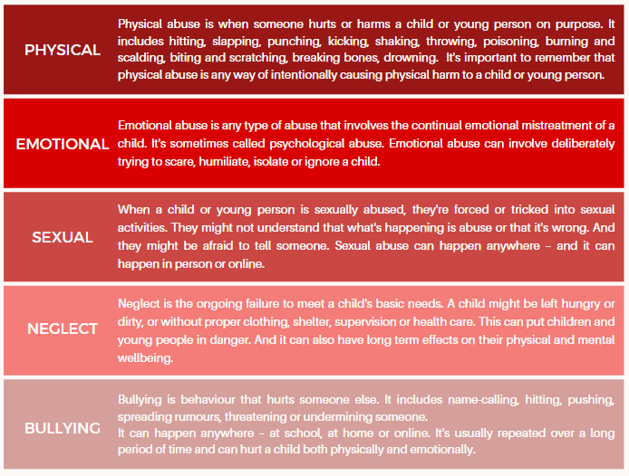
  - Child Sexual Exploitation is a form of child sexual abuse. It occurs when an individual or group takes advantage of an imbalance of power to coerce, manipulate or deceive a child or young person under the age of 18 into sexual activity (a) in exchange for something the victim needs or wants, and/or (b) for the financial advantage or increased status of the perpetrator or facilitator. The victim may have been sexually exploited even if the sexual activity appears consensual. Child sexual exploitation can also occur through the use of technology.
  - Grooming is defined as developing the trust of an individual and/or their family for the purposes of sexual abuse, sexual exploitation, or trafficking. Grooming can happen both online and in person.
  - Cyberbullying is the use of technology to harass, threaten, embarrass, humiliate, spread rumours or target another person.
  - Criminal Exploitation is child abuse where children and young people are manipulated and coerced into committing crimes. County lines are a form of criminal exploitation where urban gangs persuade, coerce or force children and young people to store drugs and money and/or transport them to suburban areas, market towns, and coastal towns.
  - Trafficking is where children and young people are tricked, forced, or persuaded to leave their homes and are moved or transported and then exploited, forced to work, or sold.
  - Domestic Abuse is any incident or pattern of incidents of controlling, coercive or threatening behaviour, violence, or abuse between those aged sixteen or over, who are or have been intimate partners or family members regardless of gender or sexuality. This can encompass but is not limited to psychological, physical, sexual, financial, emotional abuse, and so-called honour-based violence.
  - Forced Marriage is where one or both people do not or cannot consent to the marriage and pressure or abuse is used to force them into the marriage.
  - Female Genital Mutilation (FGM) is a term for a range of procedures that involve partial or total removal of the external female genitalia for non-medical reasons.
  - Peer-on-peer abuse is any form of abuse, harm, control or coercion exercised between children and young people, within intimate and non-intimate relationships. All instances of peer-on-peer abuse should be reported and recorded in line with our safeguarding procedures. ‘Sexting’ and/or the sharing of naked or semi-naked images or videos will be taken seriously and will be reported to the Police if it is thought an offence has been committed. Further guidance is available at Sharing nudes and semi-nudes: advice for education settings working with children and young people - GOV.UK (www.gov.uk)
  - Radicalisation – the process by which a person comes to support terrorism and extremist ideologies associated with terrorist groups. Children and young people can vulnerable to being groomed for the purposes of involvement in extremist activity. Issues related to radicalisation, terrorism, and extremism are covered in our Prevent Policy.
  - Fabricated or Induced Illness is a condition whereby a child suffers harm through the deliberate action of his/her main carer and is attributed by the adult to another cause.
  - Private Fostering is an arrangement whereby a child under the age of 16 (or 18 if disabled) is placed for 28 days or more in the care of someone who is not the child's parent(s) or a connected person. A ‘connected person’ is defined as a ‘relative, friend or other person connected with a child’, this is likely to be a person(s) who has a pre-existing relationship with the child. There is a mandatory duty to inform the Local Authority if a Private Fostering arrangement is made. Further guidance can be found at Private fostering - Lancashire County Council.
  - Infatuations – being absorbed with an extreme passion for something or someone, especially in a way that makes you foolish or unreasonable about it.
  - Hazing is any rituals, initiation activities, action, or situation, with or without consent, which recklessly, intentionally, or unintentionally endangers the physical or emotional well-being of vulnerable groups.
  - Poor Practice is the behaviour that falls short of abuse but nevertheless is unacceptable. These may also fall under ‘low-level concerns’ and are covered in our Low-Level Concerns Policy. All concerns should be raised and reported via CPOMS. Failure to challenge poor practice can lead to a culture of permissiveness where the rights and welfare of children and young people are compromised, and incidents could escalate.
  - If anyone working for the Club becomes aware of any of the above, it should be reported immediately following our safeguarding procedure and advice sought from the appropriate DSO or Head of Safeguarding for further support.

  - All staff are expected to respond appropriately to what they see, or are being told, about a safeguarding concern. We should be mindful that whilst we have to follow our safeguarding procedure, they are taking their first steps on the journey to recovery from a potentially traumatic event and we should ensure we do everything within our power to support all those raising a concern.
  - We should be mindful of the principles of a trauma-informed approach.
  - We should:
- Remain calm, display open body language and be prepared to prioritise the concern over all other work-related activities.
- Be aware that the person involved may display extreme emotions and we should seek to promote their safety and the safety of others in the vicinity.
- Be conscious that the person reporting a concern may have suffered previous or current trauma and may not present as we may expect in response to the situation.
- Seek out a space that affords an appropriate level of confidentiality whilst being mindful of the spaces available and that we should not be alone with a child or young person.
- Find an appropriate point early on to explain that it is likely that the information they share will need to be shared with others – do not promise to keep secrets. Be clear who you will be sharing information with.
- Listen to understand rather than to respond, and allow them to speak without interruption and at their own pace.
- Try to retain as much information in relation to the language they use to support your recording.
- Ask questions only to clarify the information you receive.
- Do not ask questions that suggest an answer as these may be considered leading questions and could negatively impact any Police investigation. Any questions should use TED – Tell, Explain and Describe.
- Reassure them that they are not to blame and they have done the right thing in telling you.
- Explain what will happen next and establish appropriate ways to contact them, and who they can contact in relation to the concern from the club.
- Be aware of forensic evidence if the concern relates to a recent incident and try to protect any supporting materials e.g., clothing.
- Report the concern at the earliest opportunity via CPOMS and if requiring an immediate response contact your departmental DSO or the Head of Safeguarding and Player Care.
  - Staff should only advise on subjects that they are qualified to do so but we encourage staff to signpost people to related local and national services should it be appropriate.
Raising a Concern
What is a safeguarding concern?
  - A safeguarding concern is:
‘any situation when there is information that a child has been harmed, or is at risk of being harmed, by their own or someone else’s behaviour’.
  - A concern could be a child protection issue, however, may also include concerns that arise through:
- Behaviour
- Attitudinal changes
- Physical injury or injuries
- An allegation
- Physical presentation
- Attendance
- Information from or observation of behaviour of a parent/carer
- Information from a third party e.g., sibling, friend, neighbour, a member of extended family etc
Information shared by another professional is not the responsibility of staff to decide if abuse is occurring, investigate welfare and safeguarding concerns or determine the truth of any concern or allegation. However, it is their responsibility to recognise and act on concerns by reporting them.
  - All staff are expected to remain vigilant in their duties and maintain an attitude of ‘it could happen here’ where safeguarding is concerned. All staff are encouraged to report and record any worries and concerns that they have and not regard anything as insignificant, adopting the approach that ‘if in doubt, report it’. On occasions, a referral is justified by a single incident such as injury or disclosure of abuse. More often, however, worries and concerns accumulate over a period of time and are evidenced by building up a picture of harm over time; this is particularly true in cases of emotional abuse and neglect. In these cases, it is crucial that staff record and pass on worries and concerns in accordance with this policy to allow relevant authorities to build up a picture and intervene with support at the earliest opportunity. Reliance on memory without accurate and contemporaneous records of concern could lead to failure to protect.
  - All concerns about a child/ren should be reported immediately, or at the earliest opportunity, and recorded in writing on the Morecambe FC CPOMS system as soon as is practicably possible. If the person is at immediate risk of harm or requires medical attention, then the emergency services should be contacted immediately by telephoning 999. If staff require immediate support or guidance regarding a concern, contact should be made with the Safeguarding Team.
  - If you are unable to contact a member of the Morecambe FC Safeguarding Team, advice can be sought from statutory agencies such as Children’s Social Care or the Police, or by calling the NSPCC Helpline.
  - If a member of staff is working away from premises controlled or contracted by Morecambe FC the safeguarding policy of that organisation should be followed. Concerns must also be reported through CPOMS and the Safeguarding Team will liaise with the other organisation.
Morecambe FC’s Safeguarding Team
  - The Club commits to identifying a Board Member who has specific responsibility for safeguarding and who is responsible for maintaining a meaningful link between the Board of Directors and the Club and will be referred to as the Club Safeguarding Board Champion. Additionally, there will be a member/s of the Club who have Designated Safeguarding responsibility and be named as Designated Safeguarding Officers and will cover all aspects of the club including matchday and the Academy. Morecambe FC Community Sports commits to identifying a Designated Safeguarding Officer who will work together with their Community Safeguarding Trustee with matters of safeguarding.
KEY CONTACTS - SAFEGUARDING TEAM
Graham Howse – Club Co-Chairman
Club Safeguarding Board Champion
grahamhowse@cwr-accountants.co.uk
07960302388
Sally O’Donnell - Head of Safeguarding & Player Care
Club Senior Safeguarding Manager
sally@morecambefc.com
07510 925175

Richard Preston – Matchday DSO
matchdaydso@morecambefc.com
Joe Shaw – Academy DSO
academysafeguarding@mfc-academy.com
07510 925063

Role of the Safeguarding Team
  - Club Safeguarding Board Champion is accountable for ensuring the effectiveness of this policy and our compliance with it. They will:
- Actively promote a culture of positive safeguarding practice, championing vigilance and action, throughout the organisation ensuring that children’s welfare is paramount.
- Ensure they have the skills, training and experience to discharge the duties of their role and take part in continuous professional development in safeguarding.
- Ensure the policy and procedures are in place, are reviewed annually, are available to the public and has been written in line with statutory guidance and local safeguarding arrangements.
- Ensure a senior member of staff is designated to take the lead responsibility for safeguarding.
- Have oversight of safer recruitment practices, ensure all staff receive a safeguarding induction and are provided with this policy and the staff code of conduct, and undertake appropriate safeguarding training relevant to their role.
  - The Head of Safeguarding & Player Care has strategic and operational responsibility for safeguarding within the club. They act as the lead for external safeguarding agencies and champion safeguarding throughout the club. They have operational oversight for all safeguarding concerns and should liaise both internally and externally where appropriate to support the safeguarding function.
  - They should:
- Have the appropriate training, knowledge and experience to perform the Senior Safeguarding Manager role and maintain their skills through regular continuous professional development.
- Have oversight of all safeguarding concerns through the electronic recording system, lead on referrals to statutory and outside agencies and support DSO’s where appropriate.
- Be available to staff to provide advice and support on issues of safeguarding.
  - Designated Safeguarding Officers are responsible for ensuring safeguarding is a key priority within their departments as well as being a point of contact should any safeguarding concerns arise. DSO’s have a duty to accurately record safeguarding concerns or allegations and report them to the Head of Safeguarding and Player Care. They should be suitably trained in their roles and maintain their skills through regular continuous professional development.
Matchday Safeguarding
  - Our ticketing policy with regards to children is:
    - No children under the age of 12 months old will be permitted entry into the open-air areas of the stadium and concourses.
  - All persons under the age of 14 must be accompanied by an adult.
  - Those young people purchasing 14-17-year-old tickets, will be requested to supply the contact details of a parent/carer.
  - All issues related to matchday safeguarding are covered in the Matchday Safeguarding Event Plan and will detail the following:
  - There will be an identified Event Safeguarding Officer (ESO) who will be responsible for overseeing and responding to any safeguarding related incidents and issues and detailing the following recording protocol.
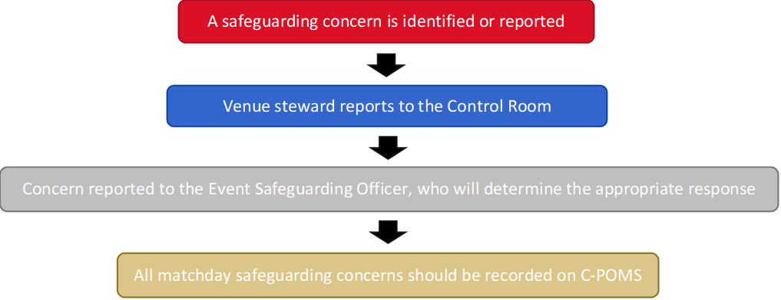
Ball Persons & Child Mascots
  - Children will be met, supervised and guided by a specified Matchday Coordinator. This role is subject to an enhanced DBS check.
  - The Matchday Coordinator is responsible for collecting ‘Matchday Consent Forms’ for all participants (ball children/mascots) in advance of the event to check any additional needs, medical conditions, any food allergies, and to gain signed photographic/video consent. This information should be relayed to the relevant departments and provided to the Event Safeguarding Officer at least 24 hours before kick-off.
  - Emergency contact details will be collected and held by the Matchday Coordinator for all participants.
Unaccompanied Children
11.9 To promote good safeguarding practice all staff are encouraged to identify any under 14-year-olds attending matches without supervision. Where it is identified that someone under 14 has not got adult supervision the Event Safeguarding Officer will be called, and measures are taken to find suitable supervision and contact being made with parents/carers to advise.
Searching of u18’s
  - Where routine searching has been deployed on matchdays this will ordinarily only apply to under 18’s bags and belongings. Where the decision has been taken by the Ground Safety Officer, due to suspicion and/or intelligence, for a search to be conducted on a child under 18 the search should be conducted by a steward of the same gender and with an adult, known to the child, being present. If no adult is available who is known to the child, the Event Safeguarding Officer will be present.

Non-collection of children
  - If a child fails to be collected following a match or activity every effort will be made to contact their emergency contact number/s by the Matchday Coordinator or Activity Supervisor. The Matchday Coordinator/Activity Supervisor will wait with the child for 15 minutes and if remaining uncollected contact should be made with the ESO/DSO. It is always advisable to ensure at least two members of staff wait with a child and preferably in a well-lit, dry/sheltered area. If no contact is made with parents/carers and the child has been failed to be collected after 1 hour the Matchday Coordinator/Activity Supervisor will report the concern to Lancashire Children’s Social Care OOH Number and be advised.
Matchday Photography
  - By entering the Ground, all persons are acknowledging that photographic images, visual and/or audio-visual recordings and/or feeds (and/or stills taken therefrom) may be taken of them and also be used, by way of example and without limitation, in televised coverage of the game and/or promotional, training, editorial or marketing purposes by the Club, the EFL or others (including commercial partners and accredited media organisations) and entry into the ground constitutes consent to such use.
  - You further acknowledge that photographic images and/or audio, visual and/or audio-visual recordings and/or feeds (and/or stills taken therefrom) may be used (by the Club or by a third party, such as law enforcement body) to identify you as an individual, where permitted by data protection laws, for the purposes of preventing or detecting crime, or any breach of the Ground Regulations. Information about the Club’s use of your personal data will be brought to your attention by the Club (see for example any applicable privacy policy, signage and/or other forms of announcement in or around the ground). For further information please contact the Club.
Use of Images and Videos
  - The use of images and video at Morecambe Football Club is to follow the below guidelines:
- Children are to be appropriately dressed in all photographs;
- The person wishing to take images must obtain clearance from the member of staff on duty;
- Photography/images must focus on the group and not the individual where possible;
- Parents/carers of children who do not wish to have their child’s photograph taken must make themselves known to a member of staff on duty;
- We forbid photography in private areas, such as changing rooms, toilets, showers or bedrooms, or whilst a child is in a state of undress.
- Within the Academy, no photography of video footage will be taken in the vicinity of any changing room or treatment room.
- Within the Academy, mobile phone use for imagery will not be allowed without the express permission of a member of the safeguarding team and should only be approved for use on a device provided by Morecambe FC. No photos should be taken on personal devices.
Departmental Safeguarding
Academy Safeguarding
  - It is acknowledged that all the players within the Academy have a right to be safe at all times as part of Morecambe FC and we should ensure the appropriate safeguards are in place for all activities. We ensure that all staff have had the appropriate employment and DBS checks, in line with EFL guidance, completed for their respective roles. We will apply trauma-informed principles and look to build trusting relationships with players and seek their feedback to provide a safe environment where they can thrive.
  - All academy activities are required to be suitably risk assessed, including measures to address any safeguarding risks and have an identifiable designated safeguarding officer and activity lead. This should be communicated effectively to enable players, parents and staff to contact the relevant staff in regards to any concerns or issues.
  - Any trips and tours for those within the Academy should follow the Travel, Trips and Tours Policy ensuring adequate staffing ratios according to players ages.
  - We will proactively champion safeguarding and our life skills programme, providing advice and support to players and parents so that they can identify safeguarding concerns and feel confident to report any concerns to the relevant staff.
1st Team Safeguarding
  - We are aware of the pressures that can be placed upon young people embarking on a professional football career and we want to ensure that they get the best out of the experiences open to them. It’s important that whilst they are part of the 1st team environment all players who are under 18 should have the appropriate safeguards in place. All activities involving under 18’s should be fully risk assessed and include measures to address safeguarding considerations. Additionally, all staff working with under 18 players should have the appropriate level of DBS check. Again, the Travel, Trips and Tours Policy should be adhered to where this applies.
  - We will work together with all players to enable them to make a smooth transition into 1st Team life whilst giving them access to appropriate support mechanisms and pastoral guidance.
Managing Allegations Against Staff
  - We aim to provide a safe environment that secures the well-being of children in receipt of a service from our organisation. All staff have a responsibility to behave with honesty and integrity at all times and comply with the club’s Code of Conduct. We do, however, recognise that sometimes allegations are made.
  - We recognise that allegations when they occur, are distressing and difficult for all concerned. We also recognise that some allegations are genuine and that there are individuals that deliberately seek to harm or abuse children.
  - We will take all possible steps to safeguard children and to ensure that those working on behalf of our organisation are safe to work with children. We will always ensure that the procedures outlined in Working together to safeguard children - GOV.UK (www.gov.uk) are adhered to and will seek appropriate advice from the Designated Officer for the Local Authority where appropriate.
  - Staff are provided with advice regarding their conduct online and in-person and are aware that inappropriate behaviour towards children is unacceptable and likely to be unlawful. At all times, their conduct towards children must be professional. In addition, staff should be aware that, that under the Sexual Offences Act 2003, it is an offence for a person over the age of 18 to have a sexual relationship with a person under the age of 18, where that person is in a position of trust, even if the relationship is consensual. This means any sexual activity between a member of staff in a position of authority and trust and a child under 18 on a Club activity may be a criminal offence, even if that child is over the age of consent. Regardless of any criminal charges information of this nature would always be passed to The FA’s Safeguarding Team who would consider the suitability of that person to work within football and could result in a temporary or permanent suspension from working and taking part in all football activity.
  - If an allegation is made or information is received about any member of staff (or volunteer) who works with children (both within our organisation or outside our organisation) who has:
- Behaved in a way that has harmed a child, or may have harmed a child.
- Possibly committed a criminal offence against or related to a child.
- Behaved towards a child or children in a way that indicates they may pose a risk of harm to children.
  - The member of staff receiving the information should inform the Head of Safeguarding immediately who will record it in Staffsafe. This includes concerns relating to agency and supply staff, trainees, interns and volunteers.
  - The Head of Safeguarding and Player Care will liaise with the Safeguarding Strategy Panel members (Club Board Champion and Club General Manager) to refer for any disciplinary procedures to be initiated.
  - Should any concerns be regarding a member of the Safeguarding Team please use this guidance:
- Concerns regarding the Academy or Matchday DSO should be raised to the Head of Safeguarding and Player Care.
- Concerns regarding the Head of Safeguarding and Player Care should be raised with the Safeguarding Board Champion.
- Concerns regarding the Club Safeguarding Board Champion should be raised with The FA Safeguarding Team or LADO.
  - The club does not have responsibility for investigating suspicions or allegations of abuse by staff but, under the direction of the Head of Safeguarding, it will notify the appropriate agencies such as the Local Authority, the Local Authority Designated Officer or the Police so that they can investigate and/or take necessary actions. Where a referral to the LADO is required, this should occur within one working day.
  - Any member of staff or volunteer who does not feel confident to raise their concerns within the organisation should contact the LADO directly.
  - Liaison and referral may be necessary to the FA Safeguarding Team in addition to this.
  - We may also seek consultation with the LADO where we believe that an individual has behaved in a way in their personal life that raises safeguarding concerns. These concerns do not need to directly relate to a child.
  - Morecambe FC will refer to the Disclosure and Barring Service (DBS) any member of staff who has harmed, or poses a risk of harm, to children. This referral will be made as soon as possible after the resignation or removal of the individual in accordance with advice from our Human Resources function.
  - Please also see our Whistleblowing Policy.

Historical Allegations
  - The club will manage any/all allegations of a historical nature in accordance with the relevant guidance from the football governing bodies and/or external agencies, including guidance from the police. In all cases, internal stakeholders will be identified and engaged to ensure an open and transparent process is undertaken, including how to gather relevant information and share this as required/appropriately.
  - Further information can be found at Section 9 - support for adult survivors - Safeguarding | The Football Association (thefa.com)
  - Or you can contact the NSPCC dedicated helpline for footballers who’ve been sexually abused.
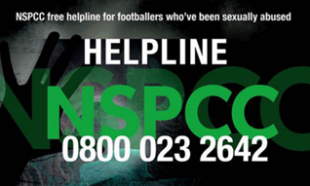
  - All safeguarding concerns regarding children and young people should be recorded on our CPOMS system.
  - Any concerns regarding staff should be reported directly to the Head of Safeguarding and Player Care and recorded on the Staffsafe system.
  - CPOMS can be accessed at www.morecambefc.cpoms.net. All Academy staff have a direct login assigned to them and Club staff should report concerns to their line manager who will log the concern on CPOMS for them. This will then be assessed by a member of the Safeguarding Team and action taken to protect the person involved.
What should be mindful of when recording?
- Ensure the date and time of the incident is clearly recorded
- Be accurate and comprehensive
- Be factual, not your interpretation or opinion
- Be made immediately following the recognition of a concern
- Contain the people present and anything that was said – using their language wherever possible
- Identify the behaviour and demeanour of the person raising the concern
- Identify any injuries using the body map.
  - Photographs should NOT be taken by staff. Taking photos of injuries can be traumatic and distressing for the complainant. If photos are required for evidence purposes, this should be done by the Police.
- What you are concerned about
- Detail any action taken, for example how you reduced risk or any discussions you’ve had with the Safeguarding Team.
Why is recording important?
  - The Club must have oversight of all safeguarding issues so that they can assess risk, provide the necessary support and level of intervention, identify patterns/themes and appropriately share information. To do this we rely on staff recording concerns and actions completely and accurately.
  - Failing to accurately record safeguarding concerns can place children, young people and the wider community at risk of significant harm.
Response
  - Where there is an immediate risk of significant harm the safeguarding team should be contacted immediately and if not, available contact should be made with a statutory agency, such as the Police or Children’s Social Care.
  - All other concerns should have a recorded acknowledgement and/or response, as appropriate, via CPOMS from their departmental DSO within 24 hours.
Confidentiality & Information Sharing
  - “Information sharing is essential for effective safeguarding and promoting the welfare of children and young people. It is a key factor identified in many serious case reviews (SCR’s) where poor information sharing has resulted in missed opportunities to take action that keeps children and young people safe.”
(Information sharing: advice for practitioners (publishing.service.gov.uk))
  - Section 47 of the Children Act 1989 authorises all agencies to share information with specialist Children’s Services, the Police and Health professionals, where there is a concern that a child is at risk of significant harm.
  - The General Data Protection Regulation (GDPR), Data Protection Act 2018 (DPA) and human rights law are not barriers to justified information sharing, but provide a framework to ensure that personal information about living individuals is shared appropriately.
  - The GDPR and Data Protection Act 2018 do not prevent, or limit, the sharing of information for the purposes of keeping children and young people safe.
  - Where possible share information with informed consent, and where possible, respect the wishes of those who do not consent to have their information shared.
  - When a safeguarding concern or poor practice concern has been identified concerning a specific child the parents/carers of that child should be informed, unless doing so would put the child, or another child at increased risk. Where a concern has been referred to a statutory agency advice should be sought from them regarding this duty before notifying parents/carers.
  - Keep a record of any decisions made regarding information sharing and the reasons for it, whether it is to share information or not. If the decision is taken to share information, then record what you have shared, with whom and for what purpose.
  - “To effectively share information:
- All practitioners should be confident of the processing conditions, which allow them to store, and share, the information that they need to carry out their safeguarding role. Information that is relevant to safeguarding will often be data which is considered ‘special category personal data’ meaning it is sensitive and personal.
- Where practitioners need to share special category personal data, they should be aware that the DPA 2018 includes ‘safeguarding of children and individuals at risk’ as a condition that allows practitioners to share information without consent
- Information can be shared legally without consent, if a practitioner is unable to, or cannot be reasonably expected to gain consent from the individual, or if to gain consent could place a child at risk
- Relevant personal information can be shared lawfully if it is to keep a child or individual at risk safe from neglect or physical, emotional or mental harm, or if it is protecting their physical, mental, or emotional well-being.”
(Information sharing: advice for practitioners (publishing.service.gov.uk))
Referring to the Local Authority
  - The Safeguarding Team will make referrals to Children's Social Care following discussion with the Head of Safeguarding and Player Care. For referral within Lancashire, we will have due regard for:
- the Pan Lancashire Procedures Guidance (https://panlancashirescb.proceduresonline.com)
- Working Well with Children and Families in Lancashire - Parts One and Two (https://www.lancashiresafeguarding.org.uk/media/19299/wwwcf-part-1-and-2-final.pdf)
- Working Well with Children and Families in Lancashire - Part Three ‘Information about Services and Support in Lancashire County Council Area’ (https://www.lancashiresafeguarding.org.uk/media/19302/wwwcf-part-3-lancs-final.pdf).
  - Lancashire’s Levels of Need are summarised in the image below:
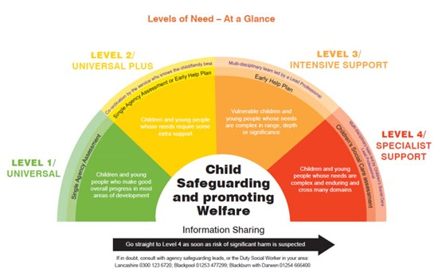
  - General concerns can be made to Children’s Social Care by contacting 0300 123 6720 (or between 8 pm - 8 am on 0300 123 6722).
  - However, where the needs of help and support meet levels 3 and 4, professionals can complete a referral/request for support form via the Multi-Agency Safeguarding Hub (MASH). (https://www.lancashire.gov.uk/practitioners/supporting-children-and-families/safeguarding-children/requesting-support-from-childrens-services)
  - If the MASH assesses the referral not to meet the threshold for statutory services, they will be passed to the Children’s Service’s Support Hub will signpost to wider early help provision.
  - Lancashire Early Help Assessment advice and guidance is available at: (https://www.lancashire.gov.uk/practitioners/supporting-children-and-families/common-assessment-framework)
Additional Safeguarding Contacts

The FA Safeguarding Team Lancashire County FA Safeguarding
safeguarding@thefa.com neil.yates@lancashirefa.com
01772 954232/644271

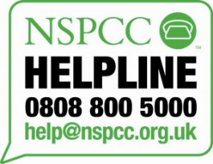
EFL Safeguarding NSPCC Helpline
safeguarding@efl.com help@nspcc.org.uk
01772 325490 0808 800 5000

Lancashire Police If you’re concern about a child contact
Lancashire Constabulary - Contact Us 0300 123 6720 or Out of Hours 0300 123 6722
101 or 01772 614444 LADO: lado.admin@lancashire.gov.uk
01772 536694

Lancashire Children’s Safeguarding Assurance Partnership
Children.cypsafeguarding@lancashire.gov.uk
01772 536954

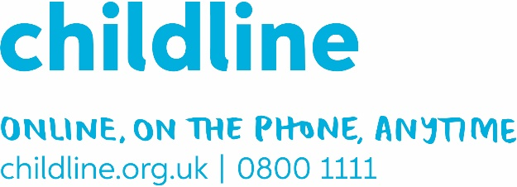
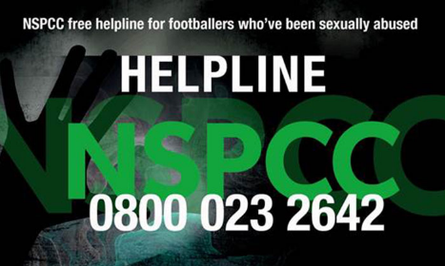
Relevant Safeguarding Legislation and Guidance
Legislation
- The Children Act 1989 Children Act 1989
- The Human Rights Act 1998 The Human Rights Act 1998
- The Female Genital Mutilation Act 2003 The Female Genital Mutilation Act 2003
- The Children Act 2004 Children Act 2004
- The Safeguarding Vulnerable Groups Act 2006 The Safeguarding Vulnerable Groups Act 2006
- The Protection of Freedoms Act 2012 Protection of Freedoms Act 2012
- Modern Slavery Act 2015 Modern Slavery Act 2015 (legislation.gov.uk)
- Counter Terrorism and Security Act 2015 Counter-Terrorism and Security Act 2015 (legislation.gov.uk)
- Children & Social Work Act 2017 Children & Social Work Act 2017
- The Data Protection Act 2018 The Data Protection Act 2018
- The Domestic Abuse Act 2021 Domestic Abuse Act 2021
Statutory Guidance
- United Nations Convention on the Rights of the Child 1989
United Nations Convention on the Rights of the Child
- The Children (Private Arrangements for Fostering? Regulations 2005
The Children (Private Arrangements for Fostering) Regulations 2005 (legislation.gov.uk)
- SEND Code of Practice: 0 to 25 years
SEND code of practice: 0 to 25 years - GOV.UK (www.gov.uk)
- Working Together to Safeguard Children 2018 Working Together to Safeguarding Children 2018 – updated 2020
- Keeping Children Safe in Education 2021 Keeping children safe in education - GOV.UK (www.gov.uk)
Other Guidance
- Standards for Safeguarding and Protecting Children in Sport (2018) CPSU
web_cpsustandards.pdf (thecpsu.org.uk)
- Safeguarding Standards for EFL Member Clubs 2021-22
safeguarding-stadards-guide_2021-22-final-version-1.pdf (efl.com)
- Working Together to Safeguard Football 2014
The FA Policy Downloads

Connected Policies & Procedures
This policy must be read in conjunction with all other policies, and in particular:

Acceptable use of IT Policy
- Adults at Risk Policy
- Anti-Bullying Policy
- Code of Conduct
- Complaints Policy
- Disciplinary and Grievance Procedure
- EFL Safer Working Practice Document
- Equality, Diversity & Inclusion Policy
- Health and Safety Policy
- Low-Level Concerns Policy
- Matchday Safeguarding Event Plan
- Prevent Policy
- Recruitment and Selection Policy
- Social Media Policy
- Trips and Tours Policy
- Whistleblowing Policy

